NAME: | Sarcol, Joshua S | DATE: | 10/08/2023

PRACTICE EXERCISE # 5.2

LE 5.21 Multiplication Table
The program will ask the user to input the number of rows and columns the table should have and display the multiplication table on screen. Use tab for the spacing between numbers horizontally.

Pseudocode: LE 5.21 Multiplication Table
START
- INITIALIZE column, row, and result as integer
- PROMPT and GET column and row
- PRINT tab
- FOR (i = 1; i <= column; i++)
  - PRINT i
- ENDFOR
- PRINT newline
- FOR (i = 1; i <= row; i++)
  - FOR (int j = 0; j <= column; j++)
    - IF j == 0
      - PRINT i
    - ELSE
      - CALCULATE result, result = i * j
      - PRINT result
    - ENDIF
  - PRINT newline
  - ENDFOR
- ENDFOR
STOP

Flowchart: LE 5.21 Multiplication Table
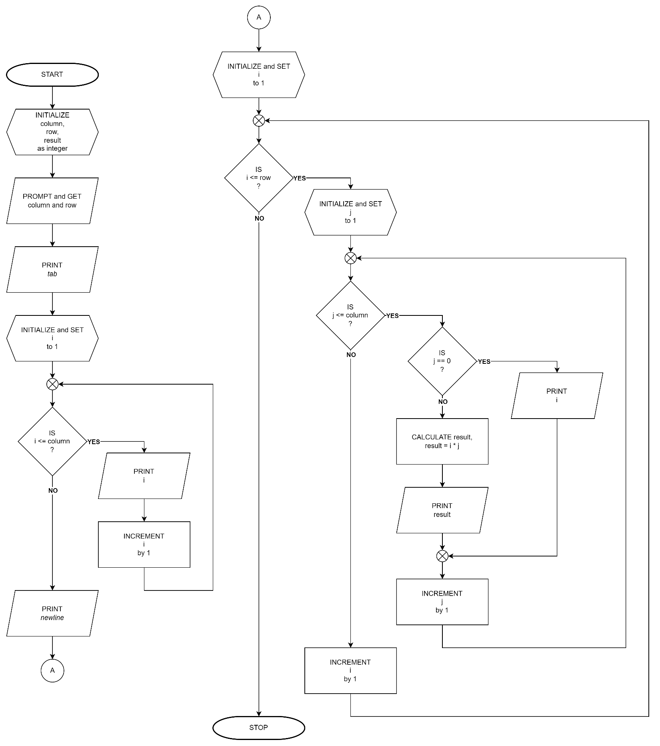

LE 5.22 Pyramid
Create a program that would display like this
Example output:
Enter a value for N: 5
1
121
12321
1234321
123454321

Pseudocode: LE 5.22 Pyramid
START
- INITIALIZE pyramidHeight and result as integer
- PROMPT and GET pyramidHeight
- FOR (i = 1; i <= pyramidHeight; i++)
  - FOR (j = - (pyramidHeight – 1); j <= pyramidHeight; j++)
    - CALCULATE result, result = i - |j|
    - IF result > 0
      - PRINT result
    - ELSE
      - PRINT space
    - ENDIF
  - ENDFOR
  - PRINT newline
- ENDFOR
STOP

Flowchart: LE 5.22 Pyramid
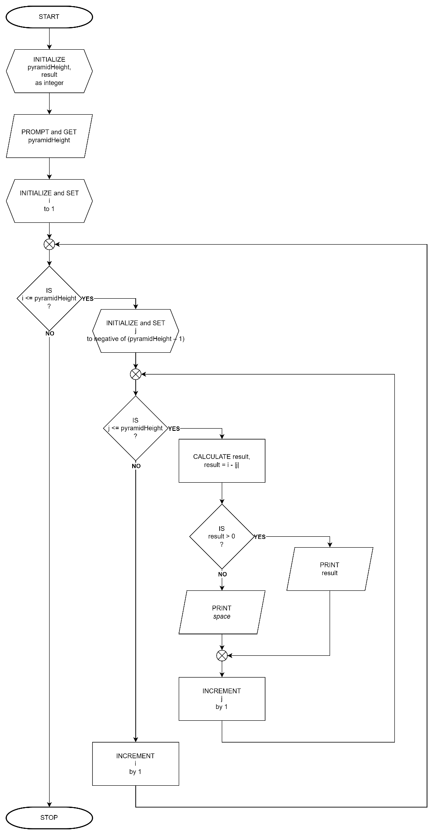

LE 5.23 Fibonacci Series
Create a program that will display the 1-N value of the Fibonacci sequence. Use a space for the spacing between numbers horizontally.
Example Output:
Enter limit: 10
Fibonacci sequence: 1 1 2 3 5 8 13 21 34 55

Pseudocode: LE 5.23 Fibonacci Series
START
- INITIALIZE terms as integer
- PROMPT and GET terms
- PRINT Fibonacci sequence:
- FOR (i = 1, n = 1, m = 0, o = 0; i <= terms; i++)
  - PRINT n
  - COPY value of m to o
  - COPY value of n to m
  - CALCULATE n, n = m + n
- ENDFOR
STOP

Flowchart: LE 5.23 Fibonacci Series
